Vehicle Booking System
User Registration Guide



LPC – VBS User Registration Guide

- Go to https://www.1-stop.biz
- Click:
- Products
- Operations
- Vehicle Booking Systems (VBS)

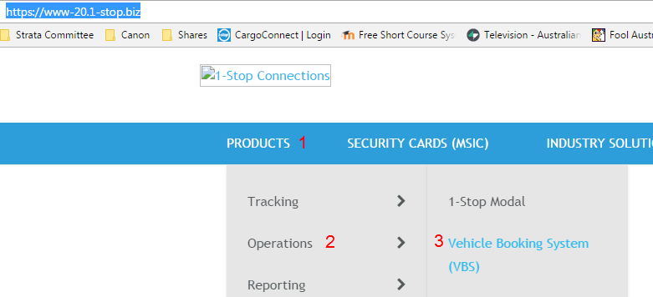

- Click on Register
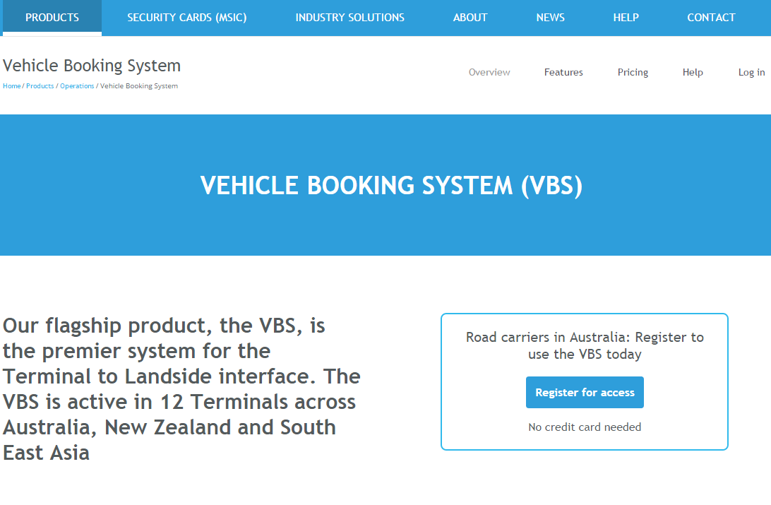

- Fill in the following form with your details and click the ‘Get Started’ button

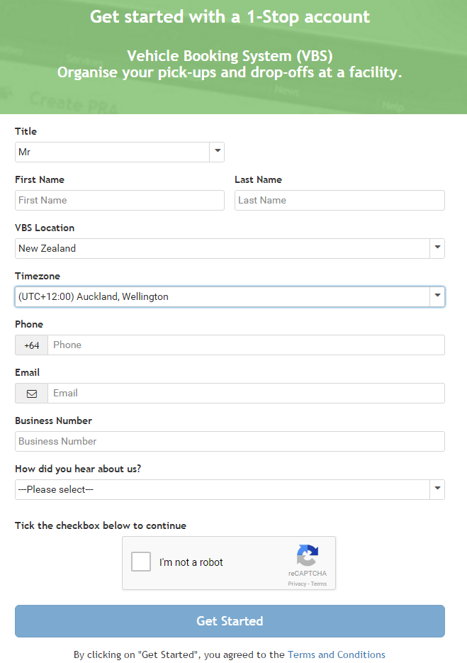

- After filling in the form on page 3 of this manual, follow the instructions on the screen
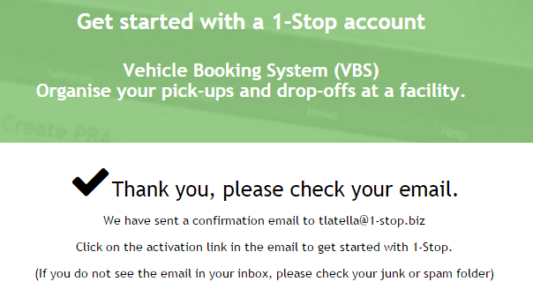

- Look for this email and click on the link provided
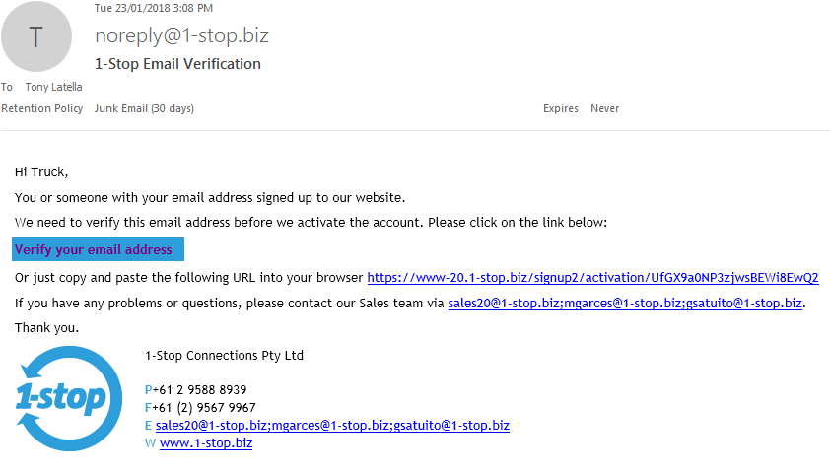

- The email will take you back to the registration site to complete your details. Be sure to select ‘LPC CityDepot Woolston of LCT Container Terminal’ as the facility
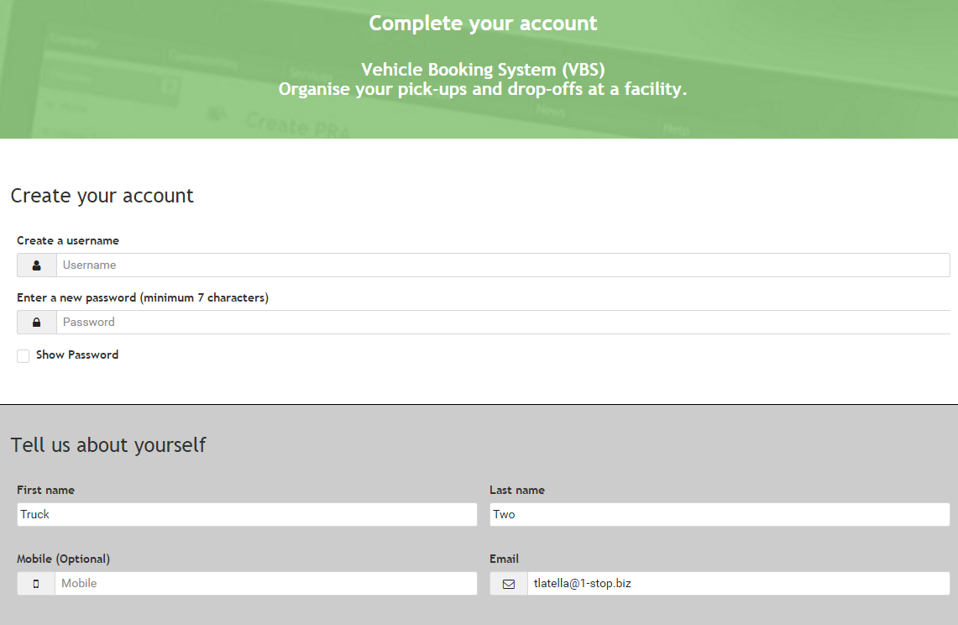
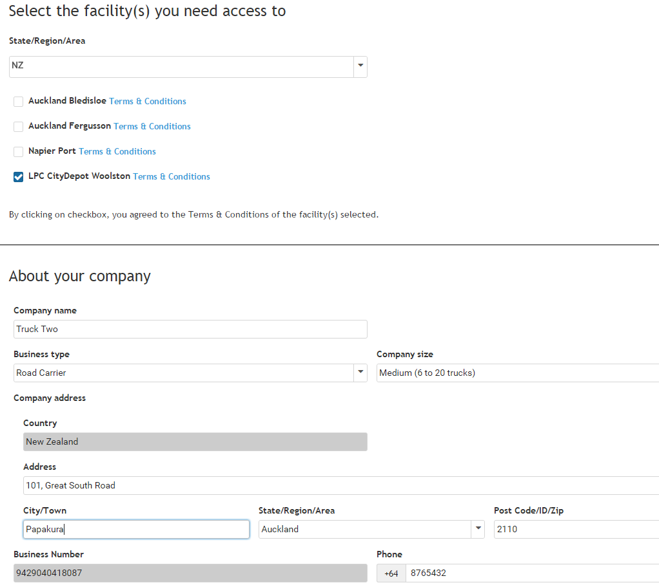
- Your registration is now complete. Your access request has been sent to LPC for approval
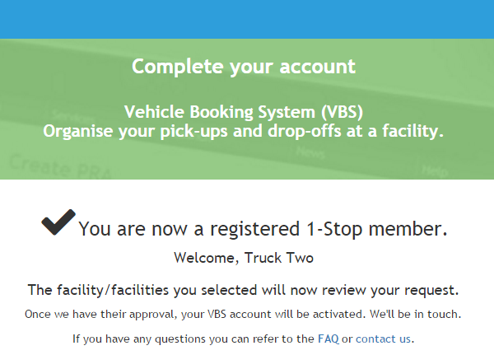

- Once LPC has reviewed and activated your account you will receive this email to let you know
