OVERALL STATUS – LCT
VESSEL SCHEDULE + CARGO ACCEPTANCE
- Click here for the current vessel schedule.

- Click here for the most up to date cargo acceptance report which is updated at 0930, 1330 and 1830hrs daily.

PORT OPERATIONS
- All areas of LCT are currently working well.

- The weekly operation updates are now available on the LPC Website. Click here for the Container operation updates.

CURRENT WEATHER
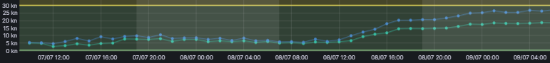
- There are no high winds currently expected throughout this week.

YARD CAPACITY + DWELL TIME
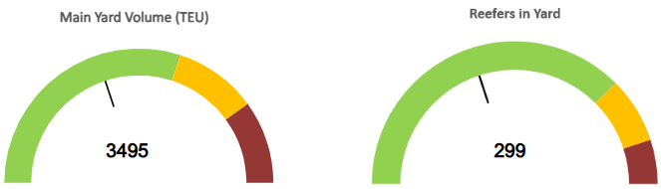
40% 40%
TRUCK TURN TIMES
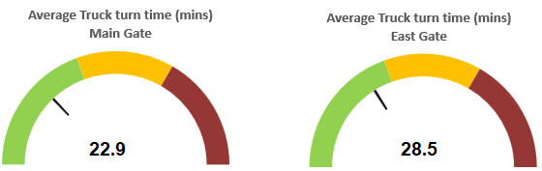
Please visit our website or contact our customer service team for real-time updates and further information.
- Customer Services – customerservices@lpc.co.nz or 03 328 7987BS – vbs@lpc.co.nz or 03 328 7976
OVERALL STATUS – INLAND PORTS
MIDLAND PORT
- There are currently both drop off and pick up bookings available throughout the remainder of today.
CITY DEPOT
- Transporters - Please continue to check the VBS notification page for low stock before sending trucks for collection.

CURRENT WEATHER
CITY DEPOT
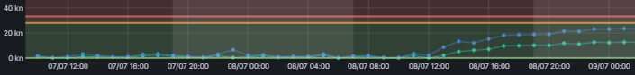
- There are no high winds currently expected throughout this week.
MIDLAND PORT
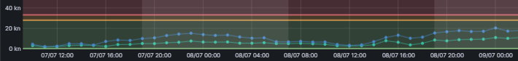
- There are no high winds currently expected throughout this week.
YARD CAPACITY
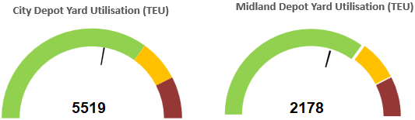
55% 54%
Please visit our website or contact our Inland Ports customer service team for real-time updates and further information.
- CityDepot – citydepotteam@lpc.co.nz or 03 328 7987
- Midland Ops –midlandops@lpc.co.nz or 03 328 7850

